# CAPSTONE PROJECT:SQL DATA ANALYSIS PROJECTA close up of a piece of paper with a pencil laying on top

# CREATE TABLE

CREATE TABLE Blink_Grocery_Data

(

Item_Fat_Content varchar(50),

Item_Identifier varchar(50),

Item_Type varchar(50),

Outlet_Establishment_Year int,

Outlet_Identifier varchar(50),

Outlet_Location_Type varchar(50),

Outlet_Size varchar(50),

Outlet_Type varchar(50),

Item_Visibility float,

Item_Weight float,

Sales float,

Rating float

)

SELECT *

FROM Blink_Grocery_Data

# COUNT HOW MANY CLOUMN IN A DATA

SELECT COUNT(*)

FROM Blink_Grocery_Data

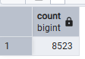

# CLEAN A DATA

UPDATE Blink_Grocery_Data

SET item_fat_content =

CASE

WHEN item_fat_content IN ('LF','low fat')

then 'Low Fat'

WHEN item_fat_content = 'reg' then 'Regular'

else item_fat_content

end

# CKECK DATA IS CLEAN

Select distinct item_fat_content

from Blink_Grocery_Data

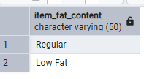

# FIND FIRST KPI

Select cast(Sum(sales)/1000000 as decimal(10,2)) as Total_sales_millions

From Blink_Grocery_Data

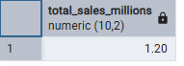

# Avg Sales

Select cast(avg(sales) as decimal(10,2)) as Avg_sales

From Blink_Grocery_Data

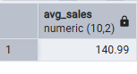

# Find No of items

Select count(*) as No_of_items

from Blink_Grocery_Data

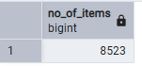

# Find Avg Ratings

Select cast(avg(rating) as decimal(10,2)) as Avg_rating

From Blink_Grocery_Data

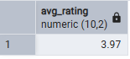

# Total Sales By Fat Content:

Select item_fat_content,

cast(sum(sales) as decimal(10,2)) as Total_sales,

cast(avg(sales) as decimal(10,2)) as Avg_sales,

count(*) as No_of_items,

cast(avg(rating) as decimal(10,2)) as Avg_rating

from Blink_Grocery_Data

group by 1

order by 1 desc

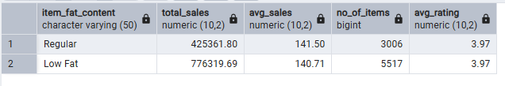

#Total sales by item type

Select item_type,

cast(sum(sales) as decimal(10,2)) as Total_sales,

cast(avg(sales) as decimal(10,2)) as Avg_sales,

count(*) as No_of_items,

cast(avg(rating) as decimal(10,2)) as Avg_rating

from Blink_Grocery_Data

group by 1

order by 2 desc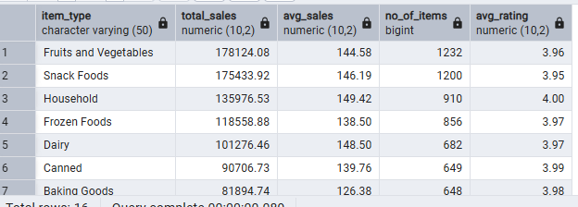

# fat content by outlet for Total sales

SELECT

outlet_location_type,

ROUND(COALESCE(SUM(CASE WHEN item_fat_content = 'Low Fat' THEN sales END)::NUMERIC, 0),2) AS Low_Fat,

ROUND(COALESCE(SUM(CASE WHEN item_fat_content = 'Regular' THEN sales END)::NUMERIC, 0),2) AS Regular

FROM

blink_grocery_data

GROUP BY

outlet_location_type

ORDER BY

outlet_location_type;

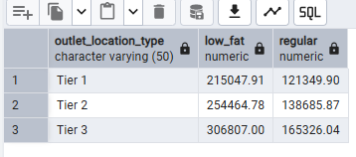

#TOTAL SALE BY OUTLET ESTABLISHMENT:

SELECT outlet_establishment_year,

cast(sum(sales) as decimal(10,2)) as Total_sales

FROM

blink_grocery_data

GROUP BY 1

ORDER BY 1 asc

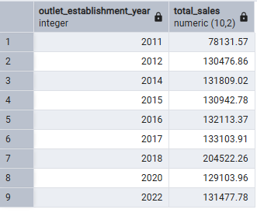

#PERCENTAGE OF SALES BY OUTLET SIZE:

SELECT outlet_size,

cast(sum(sales) as decimal(10,2)) as Total_sales,

cast((sum(sales)*100.0/sum(sum(sales)) over()) as decimal(10,2)) as Total_sales_percentage

FROM blink_grocery_data

group by 1

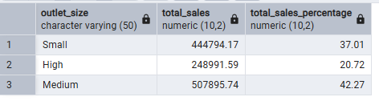

#SALES BY OUTLET LOCATION:

SELECT outlet_location_type,

cast(sum(sales) as decimal(10,2)) as Total_sales

FROM blink_grocery_data

group by 1

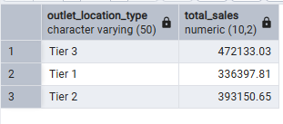

#ALL METRICS BU OUTLET TYPE:

SELECT outlet_type,

cast(sum(sales) as decimal(10,2)) as Total_sales,

cast(AVG(sales) as decimal(10,2)) AS Avg_sales,

count(*) as No_items,

cast(Avg(rating) as decimal(10,2)) as Avg_rating

FROM blink_grocery_data

group by 1

order by 1

